- Remove this sentence from all pages:
Billed every 4 weeks. Same price for every unit of this size.

- Add 3 Photos for every Unit: 00All is for all units + A + B

- Compare All Sizes
Change these
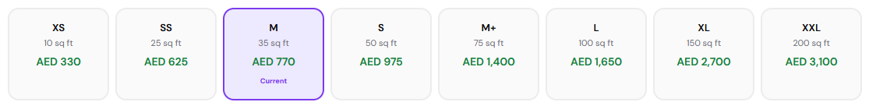
To these sizes:
XS — 10 sq ft
S — 25 sq ft
M — 35 sq ft
L — 50 sq ft
XL — 75 sq ft
XXL — 100 sq ft
3XL — 150 sq ft
4XL — 200 sq ft

- Write these information for every separate unit

10
Smart storage for the little things that take up big space.
Boxes, suitcases, seasonal clothes, ideal for studio living.
Unit 10 sq ft: Length 1m x Width 1m x Height 1.2m

25
Perfect for furniture & boxes from a 1-bedroom apartment.
Ideal for storage during moves or renovations.
Unit 25 sq ft: Length 1.5m x Width 1.5m x Height 2.4m

35
Spacious enough for a full 1-bedroom apartment.
Ideal for boxes, appliances & extra furniture.
Unit 35 sq ft: Length 2.1m x Width 1.5m x Height 2.4m

50
The sweet spot between space and price.
Fits a full 2-bedroom apartment with room to spare.
Unit 50 sq ft: Length 3m x Width 1.55m x Height 2.4m

75
Room to breathe for bigger moves.
Fits larger furniture, bulkier items & full apartment contents.
Unit 75 sq ft: Length 3m x Width 2.3m x Height 2.4m

100
Big enough for a small villa or full 3-bedroom home.
Handles larger furniture sets, appliances & cartons with ease.
Unit 100 sq ft: Length 4m x Width 2.3m x Height 2.4m

150
Serious space for serious needs.
Fits a full 4-bedroom villa or high-volume business stock.
Unit 150 sq ft: Length 4m x Width 3.4m x Height 2.4m

200
The biggest unit we offer.
Fits a full villa, major business stock, or bulky items with ease.
Unit 200 sq ft: Length 5.75m x Width 3.4m x Height 2.4m

- Frequently Asked Questions
1. Can I access my storage unit anytime?
Your belongings are always within reach. Enjoy 24/7 access, 7 days a week, using your personal access code.

2. Will my belongings be protected from Dubai’s heat?
Yes. Every PurpleBox unit is climate-controlled, with temperatures maintained at 20–24°C year-round to help protect your belongings from heat and humidity.

3. What if I need more or less storage space?
No problem. Upgrade or downsize your unit anytime, subject to availability. We’ll arrange the transfer at no extra cost.

4. Can I insure my stored belongings?
For added peace of mind, we recommend insuring your belongings. Basic coverage is available through our insurance partner at affordable rates. Ask our team for details when you reserve.

5. Can I cancel my storage plan at any time?
Yes. PurpleBox offers flexible contracts billed every 4 weeks. Simply give 14 days’ notice before your next billing date, in accordance with your contract terms.

